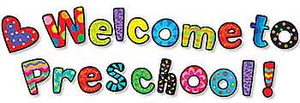
Dear Preschooler,
Before you know it, it will be time for you to come to school. We are so excited to see you! This year is going to be lots of fun! We will have a great time together. We are going to sing songs, read stories, make projects, explore the world around us and learn so many wonderful things. You will meet many new friends who will love playing and learning with you! Some of you will return and get to see your old friends again. Your teachers are so very excited to have fun with you!
See you very soon!
Your Friends,
Mrs. Alivia
Mrs. Karen

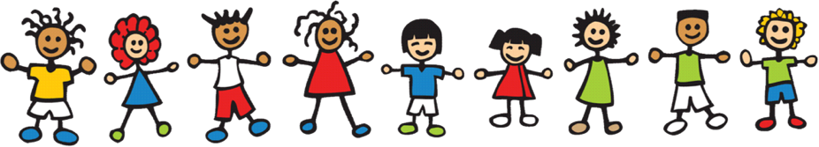
Preschool Supply List
(Please label all items with child’s full name!)
- 1-24 pk. Crayons
- 1-pk. of markers
- 1-pk. of colored pencils
- pencil box
- 1-pk. of #2 pencils
- 1-pocket-sized hand sanitizer
- Water color set
- 3 cans of playdoh (any color)
- Lanyard

Optional Items:
- 1 can of Lysol spray
- 1 container of Lysol wipes
- box of tissues
Please bring a backpack daily. In it, please keep a full set of clothes to change into. These will be kept in case of accidents.

